

**PRIVACY NOTICE – COVID-19 & GDPR**

The college will collect and process any data regarding COVID-19 which is needed to maintain the safety of students, staff and others who have dealings with the college, and to meet government requirements.

Data collected may include symptoms, test results, and contacts, and information will be shared with the agencies such as NHS Test and Trace, and public health services as necessary to meet the law and to protect students, staff and the public. Data will not be shared where it is not necessary for safety reasons or required by law.

The lawful basis for collecting and processing data will be legal obligation and vital interests

The data will be stored securely, accessible only to those who need it, e.g. HR or student support staff or relevant lecturers, and will be deleted when it is safe to do so and is no longer needed to be retained by law.

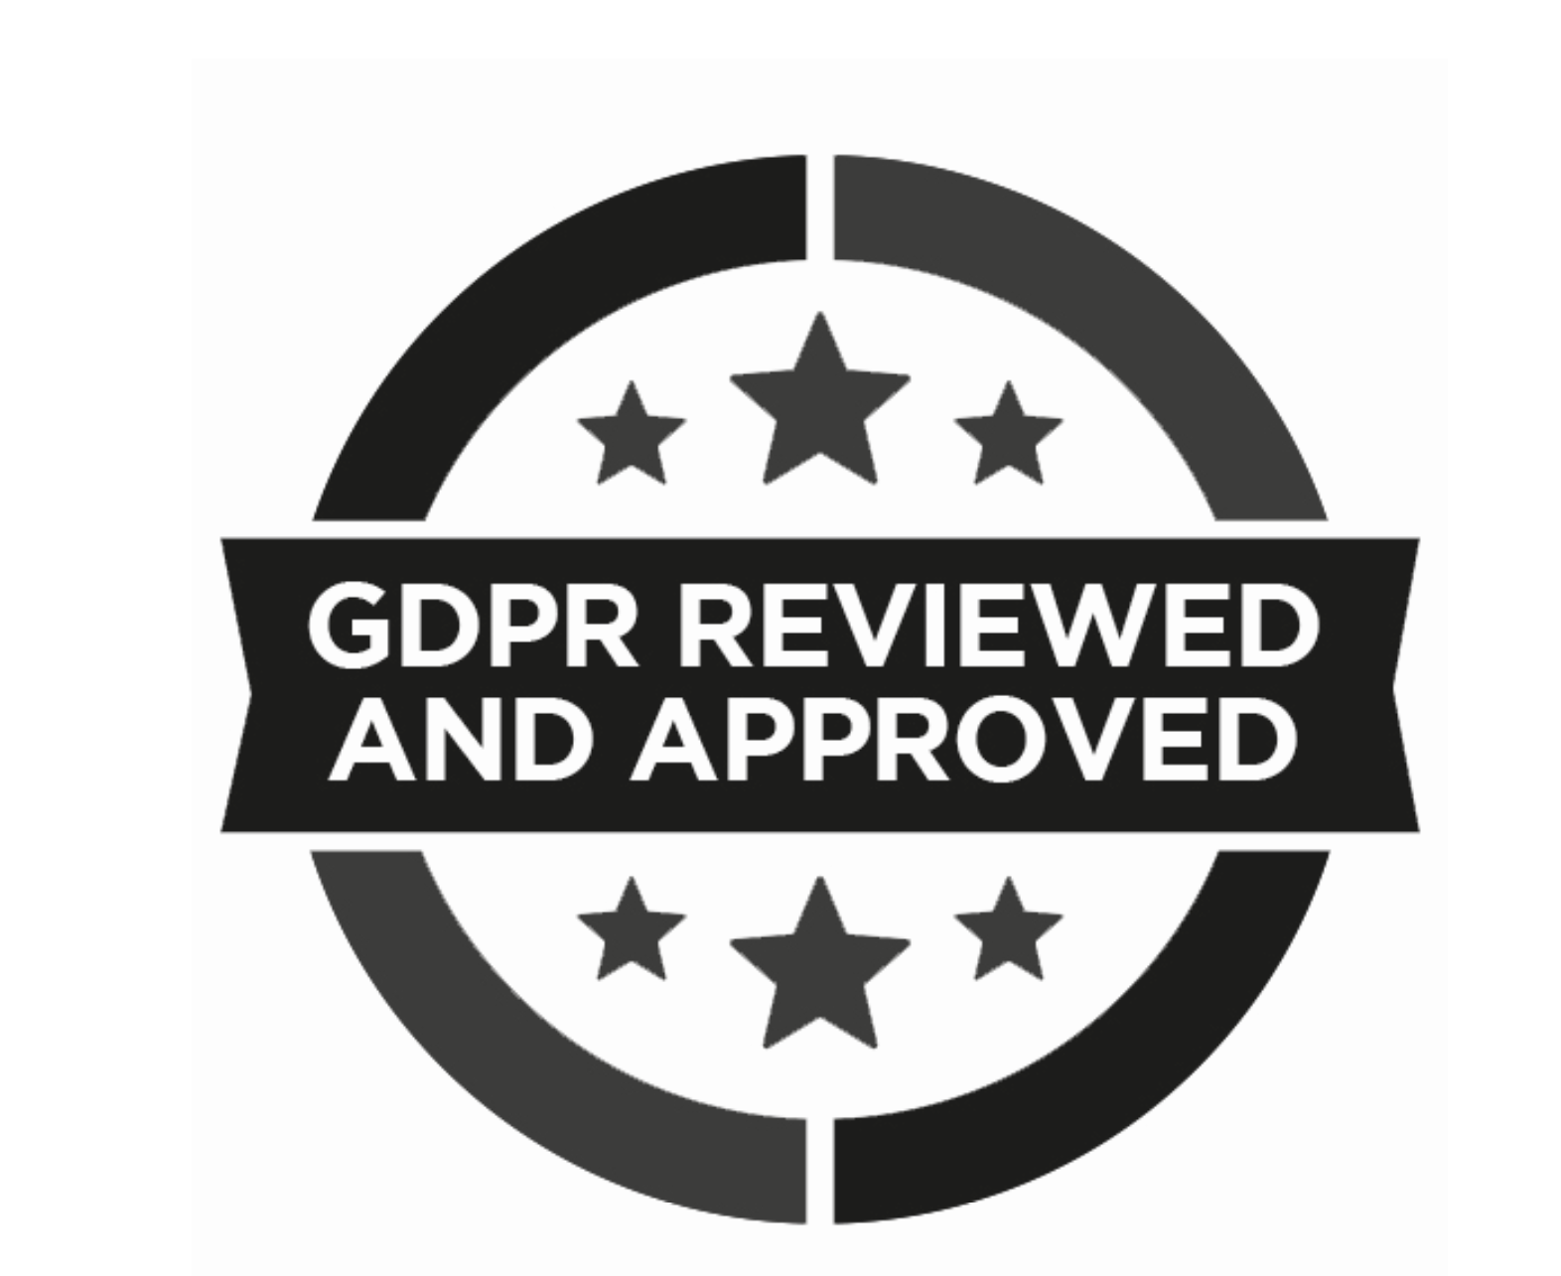

June 2020